**OVERVIEW**

MacWay Bench and floor Scales are available in several versions, offering a weighing capacity from 300 g to 3000 kg, depending on the model and customer requirements. Most commonly ordered bench scale are the MW3040 300/ 400 mm 30kg base and the1200 mm by 1200 3000kg floor pallet base. Choice of indicator combines an impressive array of powerful features.

The x320 and our marine # 820 indicators can operate as a single or dual-range scale, changing from low to high range in response to the load on the platform. The MW and RTE Series of fast, reliable and compact scales is designed and constructed to suit a wide diversity of weighing operations and wash down environments.

**FEATURES**

Packing modes colour display under/overweight indicator

**[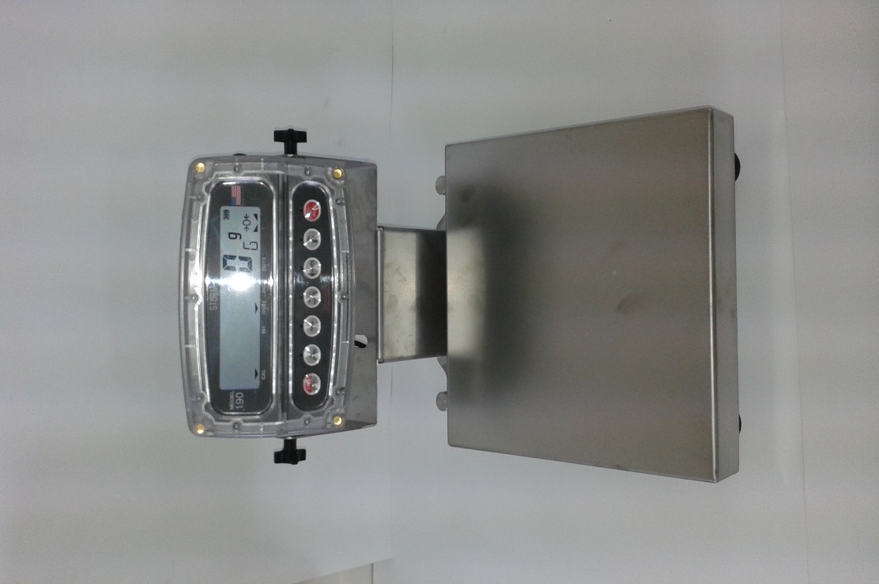](https://marel.com/images/products/m1100-10-1.png)**Pieso key boards large clear graphic display, fast response time

Motion compensation for Fishing vessel processing use at sea

Available as both single and dual-range scale

Designed to withstand the harsh conditions of a washdown environment

Water-resistant to IP67/IP69K standards

Can be operated from 230VAC internal PSU charger 80 hours run time batteries

Capable of accurately registering and recording weights in 0.4 - 1 sec.

stainless steel 304 or 316 for harsh wash down standards

**SPECIFICATIONS**

|  |  |
| --- | --- |
| **Material:** | 304 or 316 stainless steel |
| **Platform overload protection:** | Overload protection from all directions |
| **Environmental protection:** | IP67/IP69K (NEMA 6/PW12), wash-down environment |
| **Cleaning:** | with cleaning procedures in the food industry |
| **Approvals:** | Trade weighs and measure |
|  |  |
|  |  |

**Platform Scale**

* Platform size: 1.2 by 1.2 or 1.5 by 1.5 meter
* Platform size: Stainless steel or mild steel designs for most applications

**[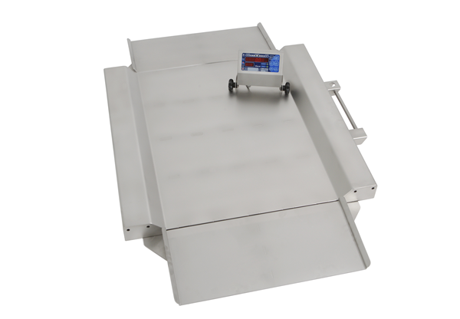](https://marel.com/images/m1100-13-1.png)M1100 PL6000**

* Platform size: 600x850 mm / 23.6x33.4 in

**[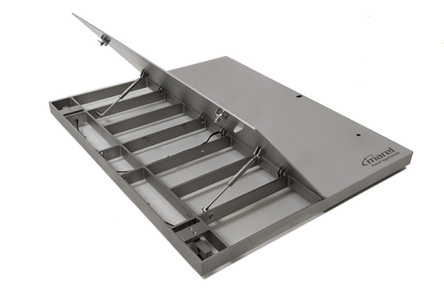](https://marel.com/images/m1100-12-1.png)M1100 PL7000**

* Platform size: 1250x1500 mm / 49.2x59.1 in
* Platform size: 1500x1500 mm / 59.1x59.1 in

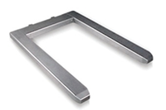**M1100 PU8000**

Outer dimensions:

Euro model: 845x1245 mm

US model: 39.8x49 in